Driven Racing Oil™ Releases GL-4 and GL-5 Gear Oils
Huntersville, NC – Driven Racing Oil™ is targeting two ends of the spectrum — old and new school — with it latest gear oils.
The new conventional 80W-90 GL-4 Gear Oil is the most basic gear oil Driven offers, protecting yellow metals and providing proper synchronization to prevent clashing in synchronized manual transmissions. Containing high quality base oils for high shear race protection and extended change intervals, it is recommended for any race or street performance application where GL-4 gear oil is required.
The new synthetic 75W-90 GL-5 Racing Gear Oil is the best gear oil in Driven’s lineup, and in the most popular viscosity. Designed to offer maximum protection in a wide range of race and street performance applications, it contains high viscosity index synthetic base oils that help lower operating temperature and reduce friction and drag in hypoid gears, spiral gear boxes and transmissions that call for GL-5 gear oil. It also provides race grade performance and performance in differentials and synchronized manual transmissions.
Part Numbers: #04530 (GL-4); Price: $9.99 (1 qt.)
#05530 (GL-5); Price: $19.99 (1 qt.)

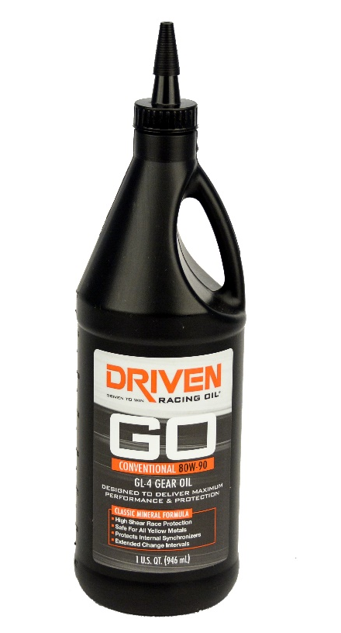
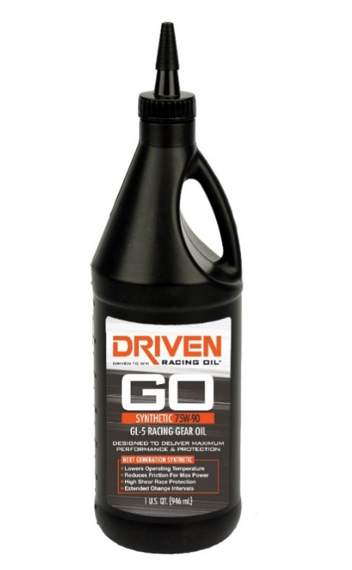

About Driven Racing Oil™
Driven Racing Oil™ utilizes cutting-edge lubricant technology and on-track research for maximum performance gains from all of its product offerings. Competition drives innovation, and Joe Gibbs Racing originally developed the Driven brand of oils to advance engine and driveline performance on the racetrack. From full-synthetic race oils to engine break-in oils and cleaners, Driven offers a wide range of race and street products that deliver performance, protection and value.

